|  |  |  |  |
| --- | --- | --- | --- |
| \\lyng-dc1\StaffShared\Learning Bugs Animals ALL subjects\characters bugs animals\Cyril the Snail - History.jpeg**Lyng Primary School Knowledge Organiser** | | | |
| **History Topic: Acient Greece** | **What was the importance of Ancient Greek creations?** | Year 5  *Civilisation, Communication and Creation* | Spring 2 |

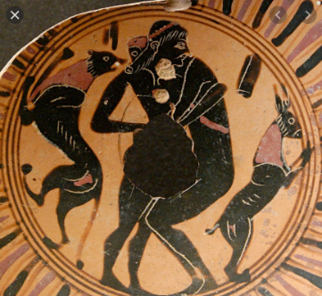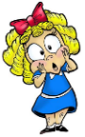

**Background information for parents and teachers.**

**Ancient Greek civilization**, the period following [Mycenaean](https://www.britannica.com/place/Mycenae) civilization, which ended about 1200 BCE, to the death of [Alexander the Great](https://www.britannica.com/biography/Alexander-the-Great), in 323 BCE. It was a period of political, philosophical, artistic, and scientific achievements that formed a [legacy](https://www.merriam-webster.com/dictionary/legacy) with unparalleled influence on Western civilization.

|  |  |
| --- | --- |
| **What Step On and Goldilocks words will I use?** | |
| **Spelling** | **Definition** |
| Assembly | In Athens the assembly consisted consisted of the group of citizens who showed up to vote. |
| Democracy | A form of government where citizens have a say in how they are ruled including choosing their leaders and deciding on laws. |
| Oligarchy | A type of government where the power is held by a few people. |
| Olympics | An athletic event held by the Ancient Greeks every four years. |
| Tyrant | The ruler of a Greek city-state like a king. |
| Alphabet | The first two letters of the Greek alphabet are alpha and beta. |
| Theatre | The idea of written drama performed by actors. |
| Myth | A traditional story, especially explaining the early history of people or explaining a natural or social phenomenon, and typically involving supernatural beings or events |

|  |  |
| --- | --- |
| When? (Timeline of key events) | |
| 2500 BC | The great Minoan civilisation |
| 1200 BC | The Trojan War and the destruction of Troy |
| 1050 - 750 BC | The Dark Ages of Greece |
| 850 - 700 BC | Development of the first Greek Alphabet |
| 776 BC | The First Olympic Games are staged |
| 650 BC | The Rise of the Greek tyrants |
| 600 BC | Greek Coin currency introduced |
| 500 – 323 BC | The Greek Classical Period |
| 490 BC | Greek/ Persian Wars led by Xerxes |
| 333 BC | Alexander the Great defeats the Persians at Issus and is given Egypt by the Persian Satrap |
| 86 BC | The Roman General Sulla captures Athens |

**Hook  
WOW DAY!**

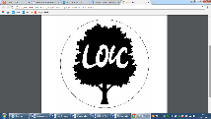

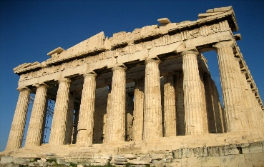



"It is the mark of an educated mind to be able to entertain a thought without accepting it."

**Great Quotes**

**Labyrinth making**

**Our Storytelling Approach to enhance engagement**

|  |  |  |
| --- | --- | --- |
| **People:**  Theseus | **Place:**  Greece | **Problem:**  A mythical beast causing problems |

**Key Facts and Famous Figures**

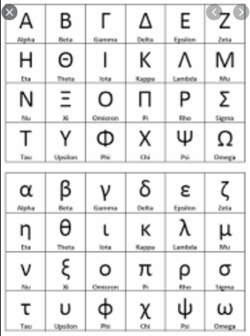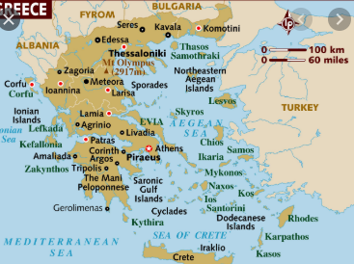

Ancient Greece was not a single country but was made up of many city states. The most famous are: Athens, Sparta and Corinth. The Minoans are the oldest Ancient Greek civilisation and originate from the island of Crete.

The city states used to fight each other. The Olympics began in Ancient Greece and were a time of peace when warring states could try to come to a peaceful agreement. The original games were held in Olympia in 776 BC and were part of a religious ceremony.

The Greeks had a lot of myths and legends which featured Greek heroes and mythical creatures. Famous Greek heroes included: Heracles (The Romans called him Hercules) Perseus and Theseus. Famous mythical beasts included: Cerberus (a three-headed dog which guarded the underworld) and The Minotaur (half bull and half man)

The Greek alphabet and language influenced us too. Our alphabet was developed using some of the alphabet that the Ancient Greeks used. In fact, the first two letters in the Greek alphabet were ‘alpha’ and ‘beta’, which is where we get the word ‘alphabet’ from! Many mathematical words are also Greek in origin, e.g. polygon, scalene, tetrahedron.

In Ancient Greece, the theatre was a very important aspect of society. Crowds of 15,000 people would gather to see a play. Theatre was so important to the ancient Greeks that prisoners would be released from gaol temporarily so they could attend. Every town had at least one theatre.

**Agreed Outcome**

Ancient Greek mythology – Green Screen

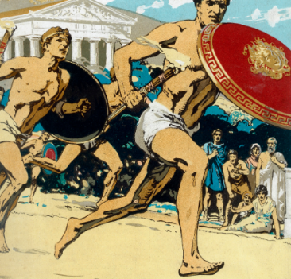

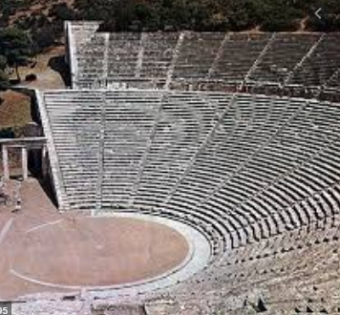

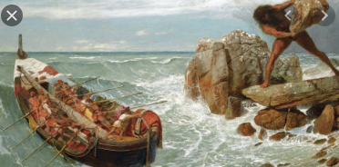

|  |  |  |  |
| --- | --- | --- | --- |
| **\\lyng-dc1\StaffShared\Learning Bugs Animals ALL subjects\characters bugs animals\Cyril the Snail - History.jpegLyng Primary School Knowledge Organiser** | | | |
| **History Topic:** | **Ancient Greece** | **Year 5**  **Civilisation, Communication and Creation** | **Spring 2** |

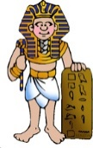

|  |  |  |
| --- | --- | --- |
| 1. Who was the head of the household in Ancient Greece? | **S** | **E** |
| Man |  |  |
| Woman |  |  |
| Slave |  |  |
| 2. Which of these activities could Ancient Greek women do? | **S** | **E** |
| Voting |  |  |
| Going to school |  |  |
| Sewing quietly |  |  |
| Going for a run |  |  |
| 3. What was the prize for winning the Olympic games? | **S** | **E** |
| Olive wreath |  |  |
| Vase |  |  |
| Silver coin |  |  |

|  |  |  |
| --- | --- | --- |
| 4. What year did the Ancient Greek era begin? | **S** | **E** |
| 7760BC |  |  |
| 146BC |  |  |
| 725BC |  |  |
| 5. How long did the Ancient Greek empire last? | **S** | **E** |
| Approx. 300 years |  |  |
| Approx. 350 years |  |  |
| Approx. 400 years |  |  |
| 6. What were the first 2 letters of the Ancient Greek alphabet called? | **S** | **E** |
|  |  |  |

|  |  |  |
| --- | --- | --- |
| 7. Name 3 creations/inventions of the Ancient Greek era. | **S** | **E** |
| 1.  2.  3. |  |  |
|  |  |  |
| 8. Very few people in Ancient Greece owned slaves. | **S** | **E** |
| True |  |  |
| False |  |  |

**Our Ancient Greek Quick Quiz**

* Who were the Greeks and when did they live?
* How was Ancient Greece governed?
* Did the Ancient Greeks give us democracy?
* How did the Ancient Greeks influence us?
* How do the modern and ancient Olympic games compare?

**Key Questions – Sequence of Learning**